- Datasync
  - Là online data transfer service giúp transfer 1 lượng lớn data tốc độ nhanh từ storage on-premises lên storage AWS hoặc giữa storage AWS với nhau
  - High-performance, secure data transfer
  - Có thể copy data thông qua
    - Network File System (NFS)
    - Server Message Block (SMB)
    - self-managed object storage
    - AWS Snowcone
    - S3 bucket
    - EFS, FSx
  - Usecase
    - Data migration
    - Archiving cold data (S3 Glacier)
  - Price
    - https://aws.amazon.com/datasync/pricing/

- Flow
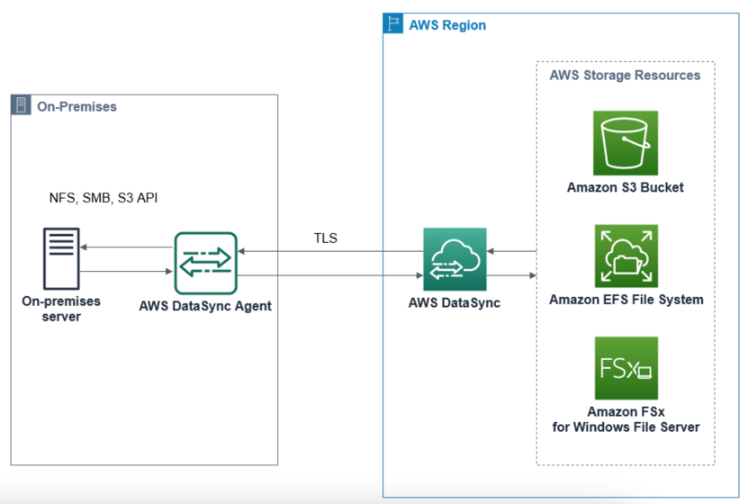  Data transfer between storage on-premises and AWS | 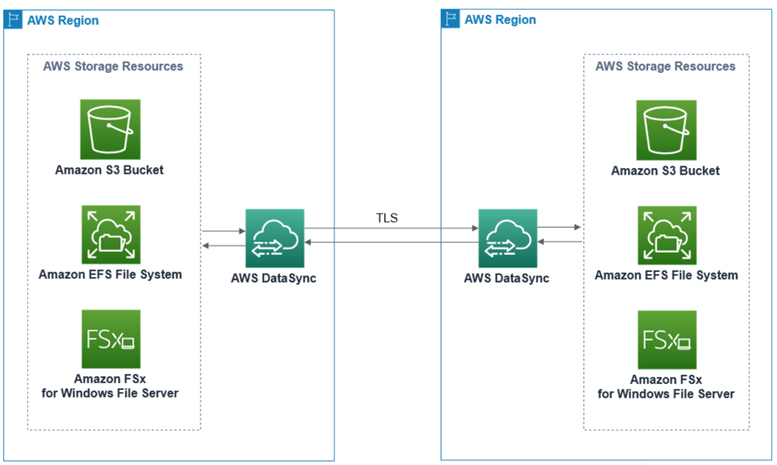  Data transfer between AWS storage services

- Các thành phần
  - Agent
    - Là VM được cài đặt ở on-premises hoặc EC2 instance để read, write data
    - Bao gồm:
      - Name
      - Hypervisor
VMware, KVM, Hyper-V, EC2 instance
      - Service endpoint
public service endpoint (data đi qua internet), VPC endpoints using AWS PrivateLink (data đi qua đường private)
      - Activation key
      - IP address
  - Task
    - Setup source & destination để thực hiện transfer data
    - Bao gồm:
      - Name
      - Source Location
        - Type: NFS, SMB, S3 bucket, EFS, FSx
      - Destination Location
        - Type: NFS, SMB, S3 bucket, EFS, FSx
      - Optional
        - Data integrity check (Validate)
        - Queue
        - Transfer mode (changing data / all data)
        - Keep deleted files / Overwrite files
        - Pattern matching
        - Schedule execute task
      - History
      - Log
        - CloudWatch
  - Sau đó execute task
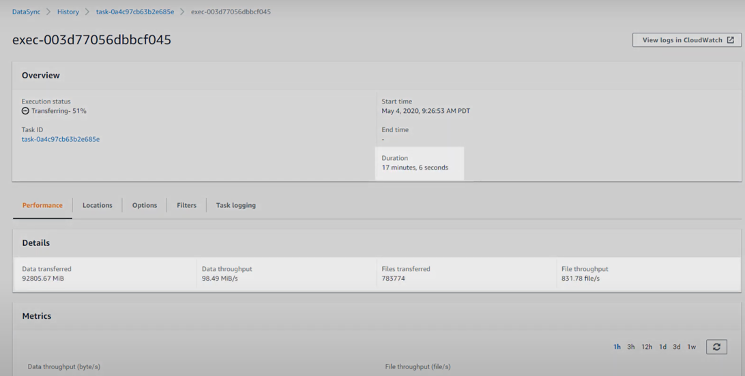

- Config
  - Setup
https://www.youtube.com/watch?v=_qhTF-gB-JE

- Reference
https://docs.aws.amazon.com/datasync/latest/userguide/what-is-datasync.html

